Tuition Assistance/Reimbursement Correlation to
Louisiana State University’s Gifted Education MEd
Academically Gifted Add-On Requirements |  | LSU’s Gifted Education MEd Course Requirements
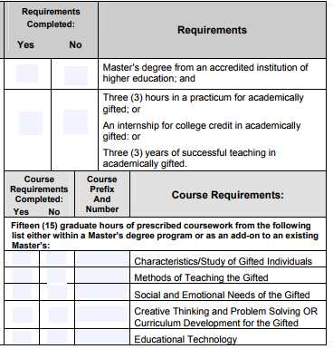 |  | 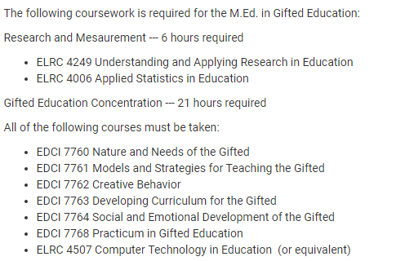
ELRC 4249 and ELRC 4006 are not eligible for Tuition Assistance or Reimbursement.

Tuition Assistance Correlation
Three hours in a practicum for academically gifted | Correlates with |  | EDCI 7768
Characteristics /Study of Gifted Individuals | Correlates with |  | EDCI 7760
Methods of Teaching the Gifted | Correlates with |  | EDCI 7761
Social and Emotional Needs of the Gifted | Correlates with |  | EDCI 7764
Creative Thinking and Problem Solving | Correlates with |  | EDCI 7762 | Participants are eligible for Tuition Assistance/  Reimbursement for one of these courses.
OR
Currculum Development for the Gifted | Correlates with |  | EDCI 7763
Educational Technology | Correlates with |  | ELRC 4507

